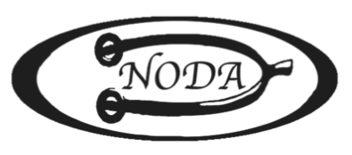

NODA Education Bingo-

Join us in a fun BINGO challenge!

The purpose of this challenge is to learn about and take advantage of all of the Education Opportunities that are available from NODA, USDF and our local professionals! And to have a lot of fun! All activities must be EDUCATIONAL.

- Print a copy or save an electronic copy of this bingo card and chart.
- Every time you complete a square, check it off on your bingo card and then fill in the separate chart with additional information.
- Free space is FREE- everyone gets this one!
- Any Five squares in a row- any direction constitutes a BINGO!
- You may play multiple times on one card or use a new copy for each game.
- You will be entered into a drawing once for each bingo.
- This bingo game will run from now until the banquet.
- We will pull names for winners three times: May 1, August 1 and at the banquet.
- There will be a special prize for everyone who turns in a 100% completed “coverall” bingo card (the entire card is filled!)

When you are done email your completed bingo card and chart to Sally schoolingshow@nodarider.org or mail to Sally Burton 8652 Beacon Hill Dr Chagrin Falls, OH 44023 to be entered into a prize drawing!

NODA Education BINGO

Name ___________________________________________

Attend any NODA educational event | Do a USDF education program  https://www.usdf.org/education/university/kb/ | Ride in any clinic | Educational activity of your choice | Audit any clinic
Audit any clinic | Find something new on the NODA website | Volunteer to do a new job at a show | Read an educational article | Do a USDF education program  https://www.usdf.org/education/university/kb/
Watch an online FEI level freestyle video | Take a lesson with someone new | Free  Space | Read a dressage book  (ex: Beth Baumert- When Two Spines Align) | Use a metronome app to find your horse’s beats per minute for walk, trot and canter
Read an educational article | Watch an online dressage related educational video | Identify and read the USEF dressage rule for permitted snaffle bits. | Write an article for the NODA newsletter or another publication | Audit a lesson with a different rider at your barn
Read an article on the online NODA newsletter | Audit a friend’s lesson with a different trainer | Look through the USDF website | Explain a dressage concept to your trainer | Pick any dressage test and read the directives

Name ___________________________________

Date | Name of event | One thing you learned

